MACH4METAL

Metalworking machinery
Transito 21,
6909 DA BABBERICH
Netherlands
Tel. +31 (0)316 – 247123
Fax. +31 (0)316 - 247956
info@mach4metal.com
www.mach4metal.com

Account No: 66.52.13.883
IBAN : NL33 INGB 0665 2138 83
BIC : INGBNL2A

UNION PC130 Floor type boring 6 AXIS
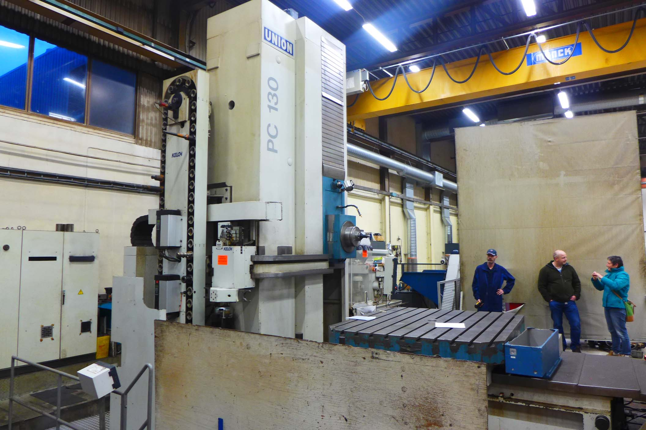
- Make : UNION Germany
- Typ : PC 130
- Mach.No : 135 000 2
- Age : 1998

- X – travel : 5.000
- Y – travel : 3.000
- W – travel : 800
- Z – travel : 700
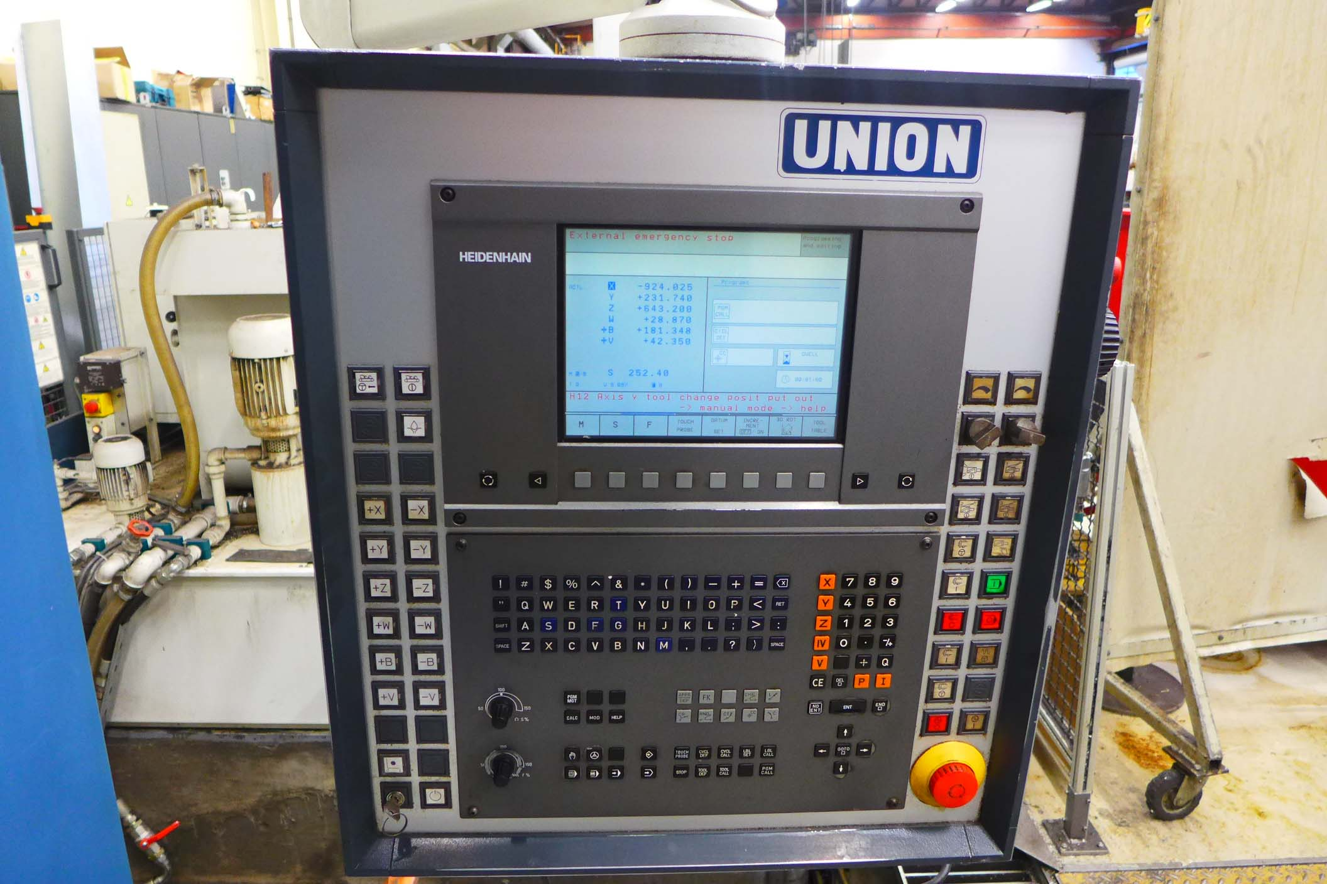
- Spindle diameter Ø : 130
- Spindle power Kw : 50
- Spindle speeds : 2.500
- Spindle taper : Sk50

- Rapid feed : 15.000 mm/Min
- Feed all axis : 6.000 mm/Min

- CNC Control Dr. Heidenhain TNC 430
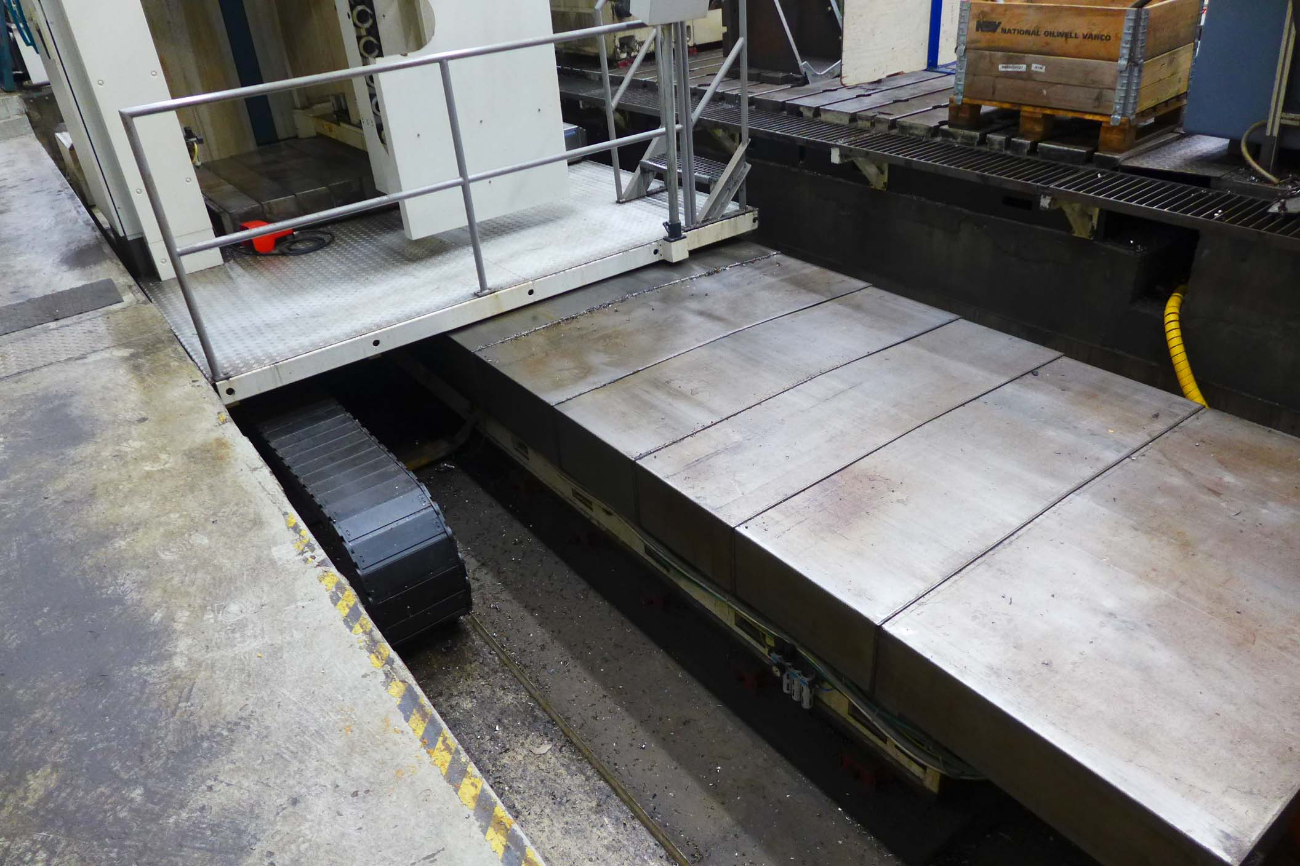
6 Axis X / Y / Z / W / V / B

- ATC Chain tool changer KELCH 60 Positions
- UNION Ti 1800 Rotary table 2.000 x 1.800
Load 12.5 Ton with B & V Axis over CNC

- Optional T Slotted floorplates
- 4 x Ca. 3.500 x 1.750 x 350 mm

- Length : 10.000
- Width : 7.240
- Height : 5.750 + 965
- Weight : 24.500

Please Note: The above information has been obtained to the best of our ability and belief from, and from the manufacturers where possible. It is given in good faith, but its accuracy can not be guaranteed. Accordingly, it will not form a representation or constitute contr actual terms. We advise you to check any vital details!

